VPC in Production like Project
Create VPC that you can use for servers in Production
- To improve resiliency deploy servers in 2 availability zones using autoscaling and Application load balancers
- Deploy servers in private subnets
- Servers receive request through load balancers
- Servers connect to internet using NAT gateway
- To improve resiliency deploy NAT gateway in both Availabitiy zones
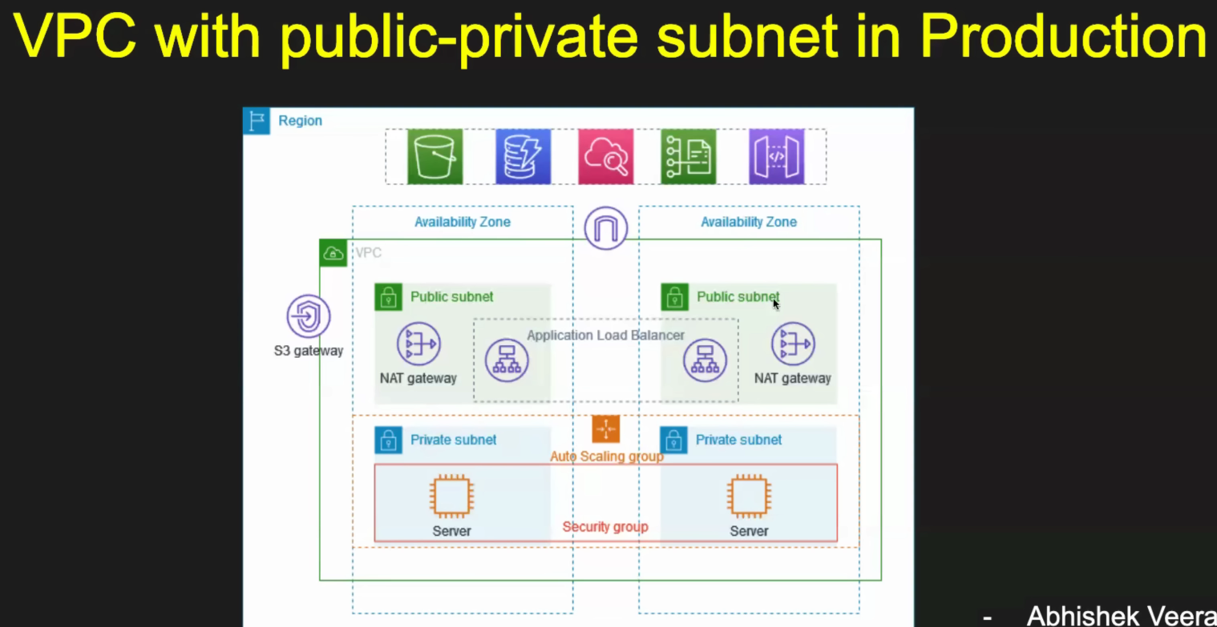

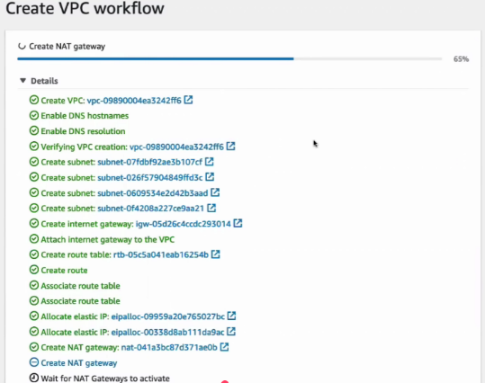
Create VPC
VPC and More
Name = PVCProdExample
IPv4 CIDR block = 10.0.0.0/16
IPv6 = No
No. of availability zones = 2
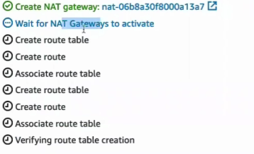
No. of Public subnets = 2

No. of Private subnets = 2
NAT gateway = 1 per Availability zone
VPC end Point = No
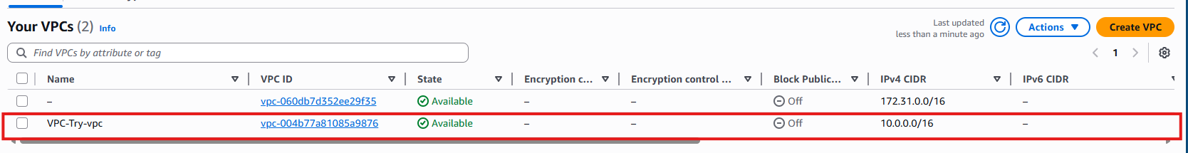
AutoScaling Group
Create Autoscaling group
- Create launch template
  - AMI – Ubuntu
  - Instance type – t2micro
  - Keypair
  - Security group
    - Select vpc created
    - Ssh from anywhere
    - Port 8000 from anywhere
  - Launch template
- Select launch template
- Select VPC
- Select 2 Private subnets
- No Load Balancer
- Size for autoscaling
  - Min – 1
  - Max – 4
  - Desired -2
- Verify if both instances are created in separated private subnets

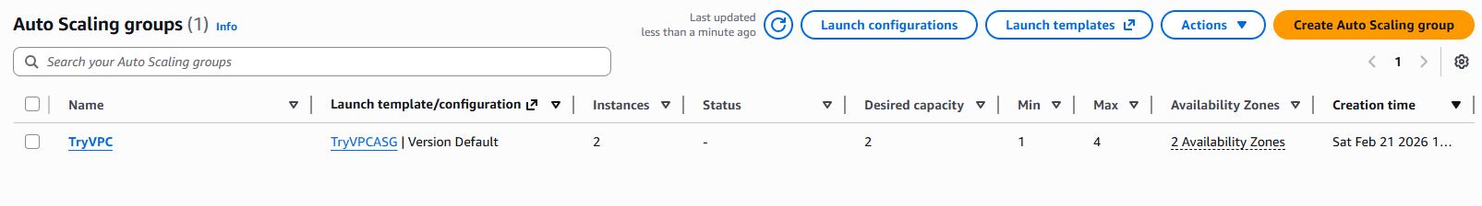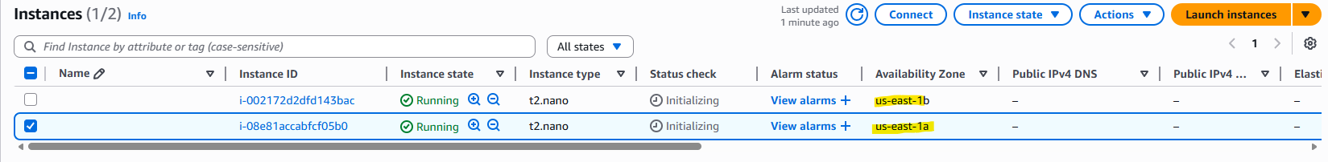

Install Application inside server in private subnets[Mostly No Public IPs]
- To connect to server in private host we need bastion host[acts as a mediator between external users or public subnets]
Create Bastion host [ec2 instance with public IP]
- Ubuntu image
- Same VPC as servers but in public subnet
- Enable public IP
- Ssh port expose in security group
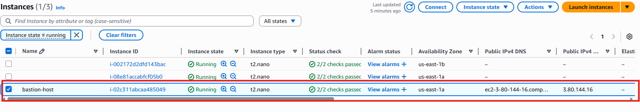
- Copy key value to bastion host to connect to server instances
From bastion host login to servers/instances in private subnet using private IP and .pem file
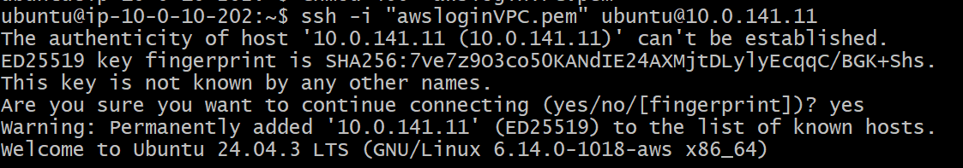
After logging in to server, create a simple html index file
and run server with this index file using python

Now server is running in one of the server in private subnet

Load Balancer
Now load balancer will route traffic to only healthy servers, so only 1 server receives all the traffic.
If it routes to other server we get server error
Create load balancer and attach 2 instances of private subnet as target group

Loadbalancer under EC2
Manage HTTP traffic from user:80 to server:8000
- Load balancer IP address type – IPv4
- Select VPC created
- Select 2 availability zones
- Select security group
- Listening and routing – HTTP = 80
- Create target group
  - Target type = instances
  - HTTPS protocol = 8000
  - Select Created VPC
  - Select 2 server instances and include as pending
- Select created target group
- Create loadbalancer
Now HTTP port 80 will be not reachable because we have not allowed in security group, edit and allow HTTP port 80
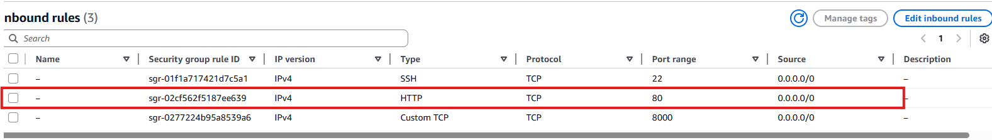
Now get the load balancer DNS endpoint and try to access server running
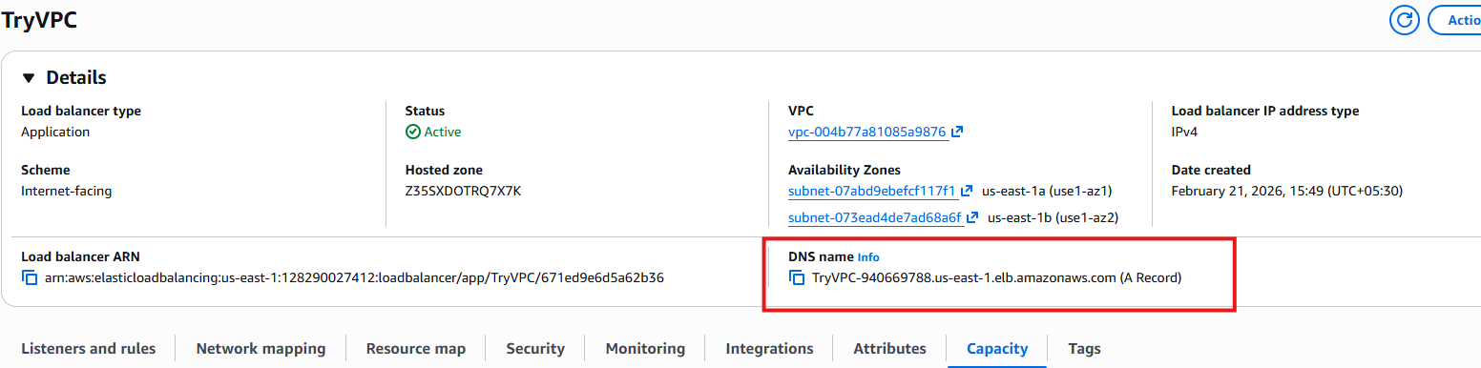
Output from application running in server1[private subnet 1]
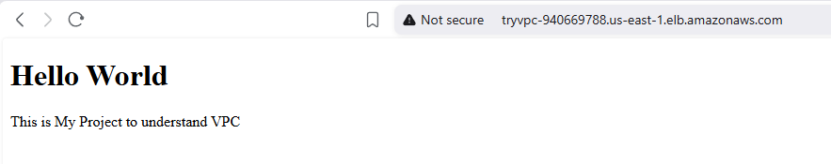
Output from application running in server2[private subnet 2]
